John P. McGovern Hall of the Americas High School Knowledge Hunt
As you explore the John P. McGovern Hall of the Americas, you'll find exhibits organized by cultural regions that showcase the diversity of Indigenous peoples across the Western Hemisphere. The hall is arranged to demonstrate connections between ancient traditions and contemporary Indigenous communities, emphasizing the message "We Are Still Here"—that these are living cultures, not just historical artifacts. This layout allows you to understand how Indigenous peoples have adapted, persisted, and thrived from ancient times to the present day, connecting traditional knowledge with modern contributions and ongoing cultural practices.
Please note: As the Museum has worked with an Indigenous Advisory Group, we have started to use the term belonging(s) to what we otherwise would have called object(s) or artifact(s). The logic here is that they once were made by and belonged to Indigenous people. Use of this term underscores the continued link—across time—between maker and their creation.
[Note: If you need more background details to answer a question than are available on the exhibit text panels, digital media, or through direct observation, you can use your phone to research additional information, if this is allowed by your teacher.]
VIDEO ANALYSIS & CULTURAL CONTINUITY
Location: Timeline Touchscreen (Entrance)
View the introductory timeline video showing Indigenous history from pre-contact through contemporary times across the Americas.
Context: Please find the large-sized timeline projected on a wall just past the Amazon diorama. It features multimedia content spanning thousands of years of Indigenous presence in the Americas. This digital display uses archaeological evidence, historical documentation, and contemporary Indigenous voices to demonstrate cultural continuity. The timeline challenges traditional historical narratives by centering Indigenous perspectives and highlighting ongoing cultural practices, political sovereignty movements, and contemporary contributions to society.
Questions:
- Using the timeline video, identify three specific examples of how Indigenous communities adapted their cultural practices while maintaining core values during periods of colonization and forced assimilation. How do these examples demonstrate cultural resilience?
- Analyze how the video timeline challenges or supports traditional historical narratives you've studied about European colonization of the Americas. What alternative perspectives does Indigenous-centered storytelling provide?
MAYA CIVILIZATION EXPLORATION
Location: Bonampak Mural Reproduction
Study the full-wall Bonampak mural showing Maya courtly scenes. This reproduction depicts events that occurred in 790–792 AD during the reign of Chan Muán, the Maya ruler of Bonampak. The original murals were created using the fresco technique, where natural pigments derived from plants were applied to wet plaster, requiring each room to be completed in a single session.
Context: The Bonampak murals are among the finest preserved Maya paintings. The site was a satellite city of the larger center Yaxchilán, located on both banks of the Usumacinta River. The paintings document the ritual life, warfare practices, and political dynamics of Late Classic Maya society.
Questions:
- What evidence can you find of political hierarchy, social structure, religious practices, and economic activities in the mural scenes?
- How do the clothing, regalia, and artistic techniques demonstrate Maya concepts of power, authority, and social status?
INDIGENOUS ADAPTATION & TRADE
Location: Totora Reed Boat & Plains Indian Beadwork
Examine the 10-foot totora reed boat from Lake Titicaca traditions and then the Plains beadwork belongings featuring European glass beads.
Context: The totora reed boat represents an ancient Andean technology still used today by the Uros people of Lake Titicaca. Totora reeds grow abundantly in the high-altitude lake environment. The boats are constructed by harvesting young, flexible reeds, drying them for durability, then weaving them into tightly bound bundles. This construction method, passed down for centuries, creates buoyant, waterproof vessels essential for transportation, fishing, and trade across this vast lake. Otherwise, trade was conducted using the extensive Incan Road system.
The Plains beadwork demonstrates the profound impact of European trade on Indigenous artistic traditions. Glass beads, primarily manufactured in Venice and Bohemia from the 16th–19th centuries, reached Native American communities through extensive trade networks. These beads often replaced traditional materials like bone, shell, copper, and stone, while maintaining cultural meanings and artistic practices.
Questions:
- How did the Lake Titicaca environment influence Andean transportation methods and construction techniques?
- What do European glass beads reveal about long-distance trade networks and cultural adaptation versus persistence?
INDIGENOUS WORLDVIEWS & NAVIGATION
Location: Inuit Inuksuk
Study the Inuit Inuksuk (stone way-finder) constructed by cultural leader Peter Irniq.
Context: This inuksuk was built by Peter Irniq, former Commissioner of Nunavut and renowned Inuk sculptor, using stones from Mexico. In Inuktitut, the language spoken by the Inuit, "inuksuk" means "likeness of a person" or "rocks that can act in the place of a person." These stone structures served as silent messengers and navigation aids across the Arctic landscape, indicating directions to good hunting or fishing grounds, safe passages, or food caches. They represent thousands of years of Inuit survival knowledge and relationship with the environment.
Note: True inuksuit do not have human-like arms and legs (those are called inunnguaq). Peter Irniq’s inuksuit feature a window or opening that points toward specific locations on the landscape. The window feature is a Peter Irniq trademark. Not all true inuksuit have windows.
Questions:
- How does this structure demonstrate Indigenous peoples’ relationship with their environment and spiritual/philosophical concepts?
- How does this compare to other ancient navigation devices or cultural monuments you’ve studied?
CULTURAL CONTINUITY & ARTISTIC EXPRESSION
Location: Raven Transformation Mask & Hopi Katsina Figures
Examine the Raven transformation mask by Kwakwaka’wakw artist Calvin Hunt (cedar and horsehair) and then study the Hopi Katsina figures (Huhuwa and Hemis Mana).
Context: The Raven transformation mask represents the sophisticated ceremonial art of Pacific Northwest peoples. Calvin Hunt, a hereditary chief and member of the prestigious Royal Canadian Academy of Arts, carved this mask from western red cedar using traditional Kwakwaka’wakw techniques. Transformation masks were worn during potlatch ceremonies to display social status and family genealogy. The masks tell stories through their ability to transform from one creature to another, often depicting how Raven brought essential gifts like salmon to the people.
The Hopi Katsina figures represent spiritual beings called katsinam that provide for and protect the Hopi people. Carved from single pieces of cottonwood root, these figures serve as educational tools given to young girls to teach them about Hopi beliefs. The Hemis Katsina is particularly significant as it appears at the important Home-Going (Niman) ceremony in July, marking the end of the Katsina season. Its colorful tablita features fertility symbols and represents hope, abundance, and prosperity. Huhuwa represents the Cross-Legged Katsina associated with harvest ceremonies.
Questions:
- How do these belongings demonstrate storytelling traditions, spiritual beliefs, and connections to the natural environment?
- What roles do these belongings play in cultural education, continuity, and religious practices compared to other civilizations you’ve studied?
RESEARCH METHODOLOGY BONUS
Choose ONE belonging you studied today and analyze:
- What belonging did you choose?
- What methods might archaeologists, anthropologists, or historians have used to study this item?
- What can this belonging tell us about the culture that created it?
- What limitations or biases might affect our interpretation of this item?
- How might working with Indigenous community members improve our understanding?

Relevant TEKS
- TEKS WH.6A – Compare civilizations
- TEKS WH.15B – Geographic influence on civilizations
- TEKS WH.22B – Religious/philosophical traditions
- TEKS WH.25A – Art reflects cultural history
- TEKS WH.28A – Analyze research methods

These photographs of specific belongings, displays, and exhibit areas are included to help you locate the items referenced in each question. The Hall of the Americas contains hundreds of fascinating objects spanning multiple cultures and time periods, so these visual references will guide you directly to the relevant displays.
Bonampak Mural Reproduction
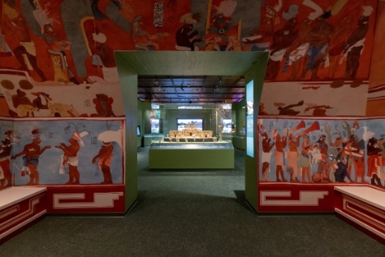
Totora Reed Boat
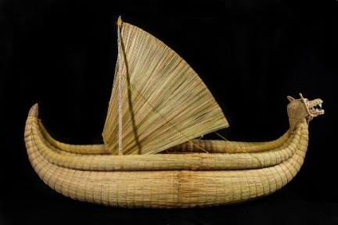
Plains Indian Beadwork
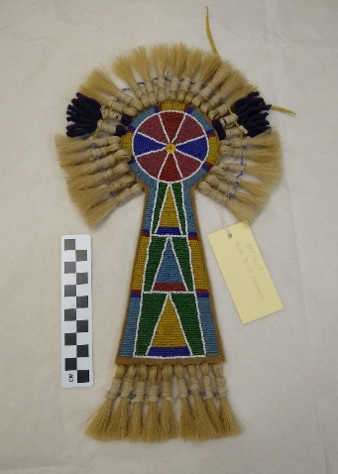
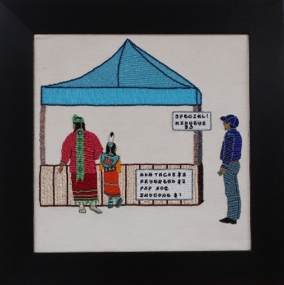
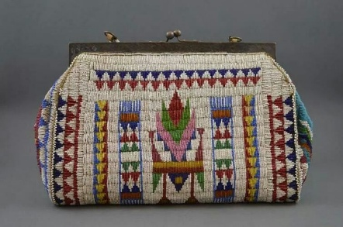
Inuit Inuksuk
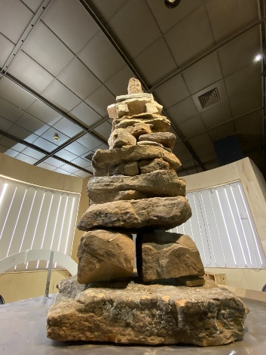
Raven Transformation Mask
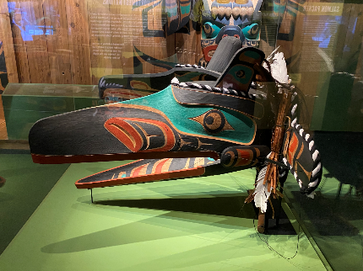

Hopi Katsina Figures
